Type of memory:
Types of Memory
● Based on Access Method
● Based on Capability
● Based on Functionality or Role
● Based on Technology

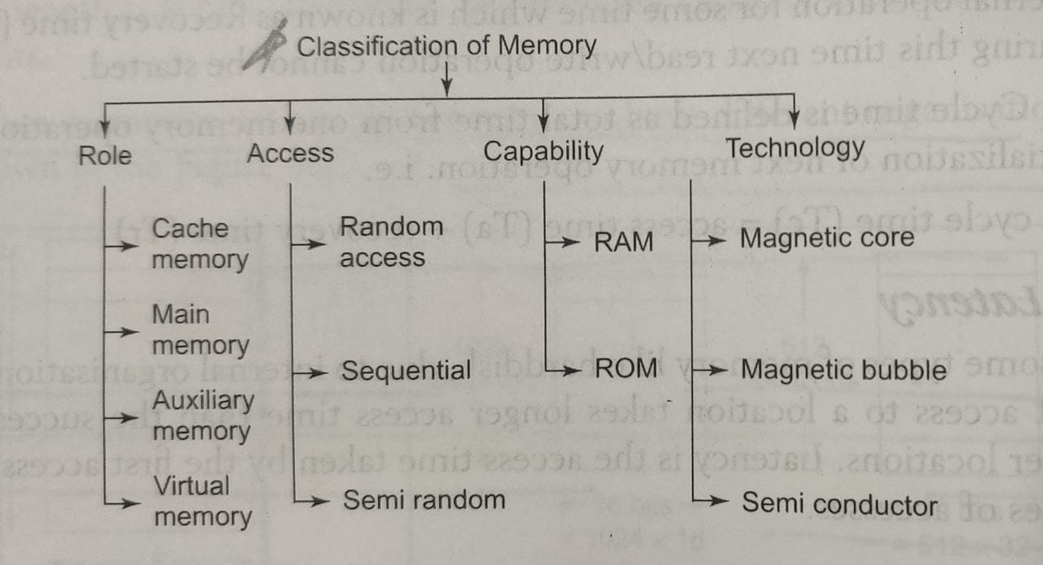

● Based on Functionality or Role

Main Memory:

Main memory is the central storage of computer system. It is relatively large and fast memory to store the programs and data during computer operation. Most of the main memory is made up of RAM (Random Access mmoery: update the storage data)chips, but portion of it is also used as ROM (read only mem) which stores programs permanently

The average time required to read the contents of a location or write into a location in main memory is called Access time. Main memory has a equal access time for all its locations irrespective of its address.Thus it is known as Random Access Memory.
After the access is over main memory needs time to settle down for the next transfer to star This is known as settling time or recovery time.
As discuss, the sum of access time and settling time is known as cycle time.

Auxiliary Memory (secondary memory)

It is also known as secondary memory. The most common secondary memory devices in our system are magnetic disks, tapes and optical disk. It stores a large amount of data and programs. As the capacity is more they are slower and cheaper than main memory. the CPU generally brings a part of the program from the secondary memory into main memory and thus it treats secondary devices as peripheral devices.

Cache memory:
Cache Memory

Cache memory has small capacity compared to main memory, but is

relatively faster and expensive. Analysis of large programs have shown that at a particular point of time, references to memory tend to be confined within few localized portion in memory. This is known as locality of reference. For example in a program the function and subroutines are called frequently. The CPU refers repeteadly the function in memory. Every time the function or subroutine is called, the same set of instructions are fetched from the memory. Thus they tend o localize the reference to memory. Similarly the memory references to data also tend to be localized. The result of all these observations shows that only few of the localized portion of memory are referred repeatedly whereas the other areas are used very less.

If these repeatedly used portions of program are placed in a small and fast memory than the access time can be reduced thus reducing the execution time of the program. Such small and fast memory is referred to as Cache memory. It is placed between the CPU and the main memory. Cache memory is the fastest in memory hierarchy and works nearly with speed of processor. The cache memory can be of two types:

1. Unified cache: it is a common cache memory that can store both instructions and data
2. Split cache: it has a separate cache to store instructions and data We will discuss more about cache memory in next chapter.

virtual memory:
Virtual memory is a concept used to construct large programs though the physical memory has limited space. The operating system keeps the large program in the secondary memory and brings only a part of the program in main memory. The address generated by the CPU is known as virtual address. The user is given an illusion of a large memory for his use, even though the system has small main memory.

https://www.youtube.com/watch?v=53yzGMABHVc

● Based on Access Method

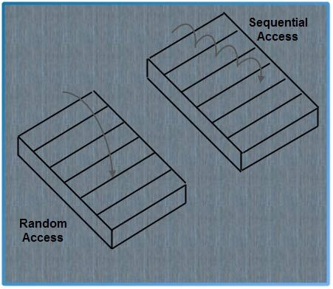
It is termed as the method to access the different locations of memory. Main memory is a Random Access Memory as any location can be accessed within same access time. i.e. access time is constant and independent of the location accessed. Semi conductor memory is example of Random Access Memory.

In sequential access memory, the location to be accessed is brought under the read/write head. The read-write head is shared by the storage locations. They must be assigned to different locations at different times either by moving the storage location or read-write head or both. Many sequential access memories operate by moving the stored information around a closed path known as track. A particular location can be accessed when it passes the fixed read-write head. Thus the acces time depends on the location. Magnetic tape is example of Sequential Access Memory.

In Semi Random Memory, access to the location is done by (1) one random access and (2) one sequential access. Hard disk and floppy disk are examples of Semi Random Memory. These memory devices contain many rotating storage tracks. If each track has its own read-write head, the tracks can be accessed randomly, but access within the track is serial.

● Based on Capability

RAM: Random Access memory
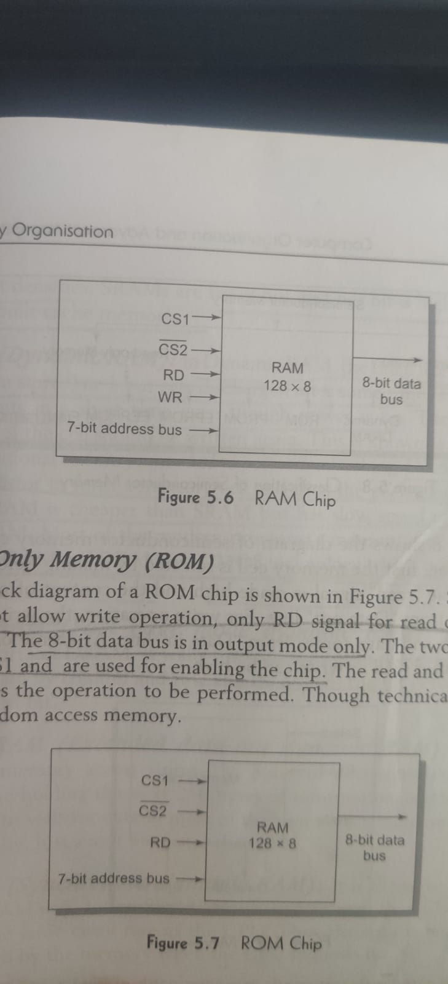
It allows both read and write operation. It is also known as RAM (Random Access Memory). The block diagram of a RAM chip is shown in Figure 5.6. The memory capacity is 128 words having word length of 8 bits Thus it requires a 7-bit address (as 128=2⁷) and an 8-bit bidirectional data bus. The RD (read) and WR (write) signal indicates the operation to be performed. The two chip select lines CSI and CS2 are used for enabling the chip when it is selected by the microprocessor. When CS1-land CS2-0, the chip is activated.

The bar on the chip select signal indicates that it is an active low signal i.e. it gets activated when it is equal to 0. Using more than one control input to select the chip facilitates in decoding the address lines when multiple RAM chips are used.

Read Only Memory (ROM)
The block diagram of a ROM chip is shown in Figure 5.7. Since ROM does not allow write operation, only RD signal for read operation is present. The 8-bit data bus is in output mode only. The two chip select lines CSL and are used for enabling the chip. The read and write signal indicates the operation to be performed. Though technically ROM is also random access memory.

● Based on Technology

Earlier, mainframes and minicomputers used magnetic core memory but nowadays they are replaced by semiconductor memories Magnetic core memories required more power and were slow. They were non volatile in nature i.e. the contents of memory did not get erased after the power is removed. But after every read operation it is necessary to perform a write operation to restore its contents. Thus, the cycle time is more.

Semiconductor memory consumed less power, has low access time (fast) and the write operation was not needed after every read operation Semiconductor memories are of two types as shown in the Figure 5.8.
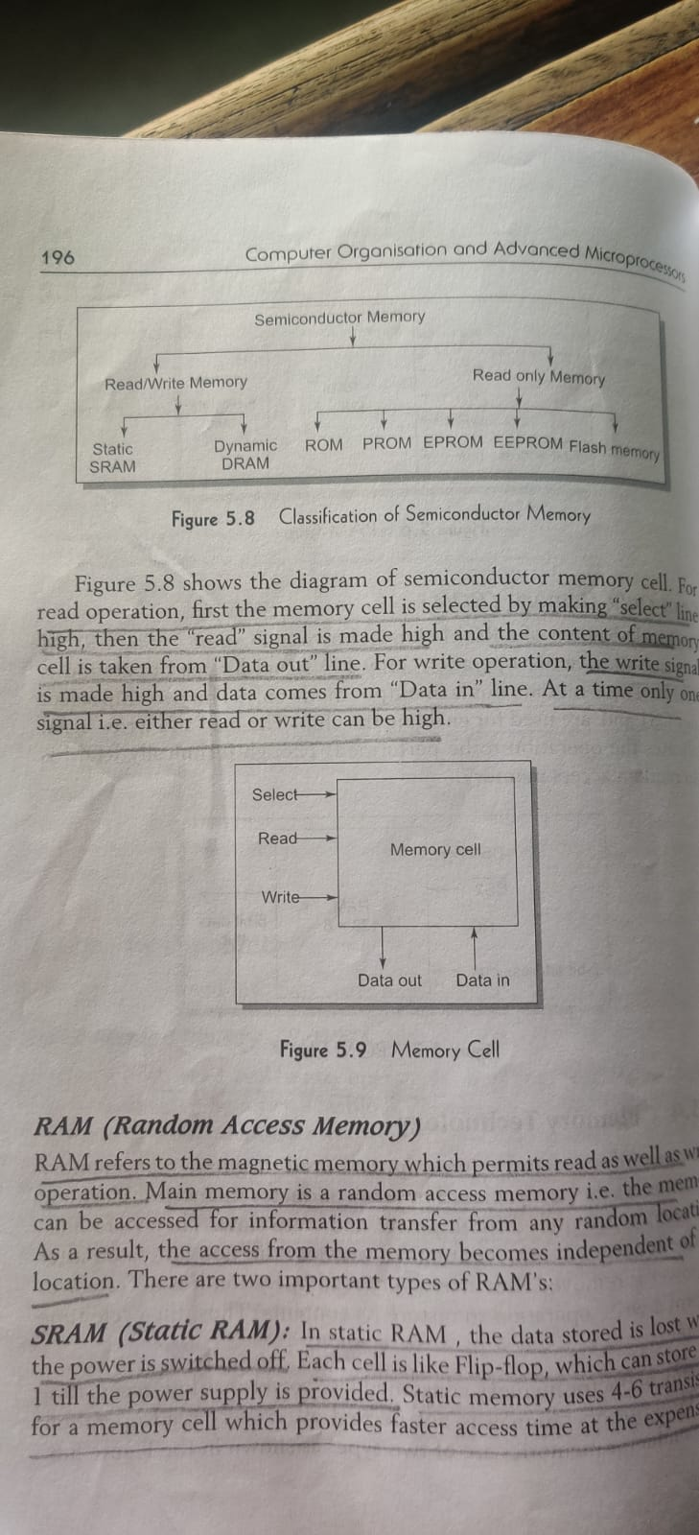

RAM (Random Access Memory)

RAM refers to the magnetic memory which permits read as well as write operation. Main memory is a random access memory i.e. the memory can be accessed for information transfer from any random location. As a result, the access from the memory becomes independent of the location There are two important types of RAM's:

SRAM (Static RAM): In static RAM, the data stored is lost when the power is switched off Each cell is like Flip-flop, which can store Dar 1 till the power supply is provided.

DRAM (Dynamic RAM): In Dynamic RAM, the cell is like a capacitor which can store 0 or 1 but gets discharged after some time. Thus it loses its contents in a short time even though power is on Therefore, the contents of the cell should be written again. This is known as refreshing. DRAM is cheaper than SRAM but has slow speed of operation than SRAM. Most of the modern processor's memory is composed of DRAM. SRAM and DRAM use CMOS technology which consumes less power

Type of DRAM::
FPM Dram: First page mode DRAM
EDO Dram: Extended data-out DRAM
SDRAM: Synchronous DRAM
DDR SDRAM: Double data rate synchronous DRAM
RDRAM:Rambus DRAM
Dual ported DRAM
SIMM and DIMM: Single inline and Double inline.

ROM

The Read Only Memory is classified into the following types:

ROM: ROM (Read Only Memory) is a non erasable storage device which has the data fixed in it at the time of manufacture. It is possible to read from ROM but data cannot be written on or deleted from it. ROM's are cheaper than RAM's when produced in large volumes.

CD-ROM is an example of this type of memory. The different variations of ROM are given below:

PROM (Programmed Read Only Memory): It is a field programmable device. As in ROM the contents cannot be modified after manufacturing, PROM gives the facility to the user to program ROM as per his requirements. But once programmed, the contents cannot be deleted. It is cheaper as the user purchases the chip from the market and programs it rather than order the ROM with the manufacturer. A special equipment PROM programmer is used to store programs in a PROM.

EPROM (Erasable Programmable Read Only Memory): EPROM as the name suggests allows the contents of PROM to be deleted by using ultraviolet rays. The chip has to be removed from the system to be exposed to UV light. Deleting one or more locations is not possible but the entire contents of EPROM are erased. Thus, contents of PROM which is used as ROM in a system can be erased and reprogrammed to suit the changed requirements.

EAROM (Electrically Alterable ROM) or EEPROM (Electrically Erase PROM))

In EAROM the contents are deleted electrically. The contents of any location can be altered without erasing the complete contents. It can be reprogrammed and erased more than 10,000 times. Also it requires less time to erase the data i.e. few milliseconds as compared to EPROM which takes 10-20 minutes.

Flash Memory

It is a special type of EEPROM which can be modified and erased in blocks of words in one operation. Individual words can also be erased and modified. It uses one transistor for memory cell resulting in high packaging density, low power consumption and low cost. Due to its low power consumption it is used in battery driven digital devices like mobile phones, digital cameras etc. They are faster but costly.

https://www.youtube.com/watch?v=PBDp50COwRk

